# ELECTRONIC SKIN

### A Seminar report submitted to

**Jawaharlal Nehru Technological University Kakinada, Kakinada In partial fulfillment of the award of degree of**

### Bachelor of Technology In

**Electronics and Communication Engineering**

### Submitted by

**B. RAMI REDDY (17X91A0415)**

### Under the esteemed guidance of Mr.S.RAJESH, M.Tech.,

**Assistant Professor**



**DEPARTMENT OF ELECTRONICS AND COMMUNICATION ENGINEERING**

**SRI SATYANARAYANA ENGINEERING COLLEGE ONGOLE**

### (An ISO 9001:2008 Certified Institution)

**(Approved by AICTE, Affiliated to J.N.T.U.K, KAKINADA)**

## Ongole-523001, A.P.

**2017-2021**

# SRI SATYA NARAYANA ENGINEERING COLLEGE ONGOLE

## (An ISO 9001:2008 Certified Institution)

**( Approved by AICTE, Affiliated to J.N.T.U KAKINADA) Ongole-523001,A.P,**

## DEPARTMENT OF ELECTRONICS AND COMMUNICATION ENGINEERING

**CERTIFICATE**

This is to certify that the seminar report titled “Electronic Skin” is the bonafied

work carried out by

## B. RAMI REDDY (17X91A0415)

in partial fulfillment of the requirements for the award of Bachelor of technology in Electronics and Communication Engineering J.N.T.U.K, during the academic year 2017-2021.

## Seminar Guide Seminar Co-ordinator H.O.D

**Mr.S.RAJESH M.Tech., Mr.G.VIJAYA KIRAN M.Tech., Mr.G.VIJAYA KIRAN**

**M.Tech.,**

**Assistant professor. Associate professor. AssociateProfessor.**

## EXTERNAL EXAMINER

### ABSTRACT

Electronics plays a very important role in developing simple devices used for any purpose. In every field electronic equipments are required. The best achievement as well as future example of integrated electronics in medical field is Artificial Skin. It is ultrathin electronics device attaches to the skin like a sick on tattoo which can measure electrical activity of heart, brain waves & other vital signals. Artificial skin is skin grown in a laboratory. It can be used as skin replacement for people who have suffered skin trauma, such as severe burns or skin diseases, or robotic applications. This paper focuses on the Artificial skin(E-Skin) to build a skin work similar to that of the human skin and also it is embedded with several sensations or the sense of touch acting on the skin. This skin is already being stitched together. It consists of millions of embedded electronic measuring devices: thermostats, pressure gauges, pollution detectors, cameras, microphones, glucose sensors, EKGs, electronic holographs. This device would enhance the new technology which is emerging and would greatly increase the usefulness of robotic probes in areas where the human cannot venture. The sensor could pave the way for a overabundance of new applications that can wirelessly monitor the vitals and body movements of a patient sending information directly to a computer that can log and store data to better assist in future decisions. This paper offers an insight view of the internal structure, fabrication process and different manufacturing processes.

### ACKNOWLEDGEMENT

I would like to express our profound sense of gratitude and indebtedness to my Seminar guide **Mr.S.RAJESH M.Tech**., Assistant Professor and **Mr.G.VIJAYA KIRAN M.Tech.,(P.hD)** Associative Professor H.O.D of E.C.E Department SSN Engineering college, for the valuable guidance and inspiration rendered by him for seminar work. Mere words would not be sufficient to place on the record the erudite guidance, sustained encouragement, constructive comments and inspiring discussions with for my seminar work

I honorably express my thanks to Seminar Incharge

**Mr. G.VIJAYA KIRAN M.Tech .,(P.hD)** Assistant Professor for providing me an utmost congenial atmosphere to carry out our seminar work.

I would like to express our deep sense of gratitude to all staff members of Electronics and Communication Engineering Department, SSN Engineering college, Ongole for their support in various aspects in completing this Seminar work.

I would like to place on record the valuable academic support given by my principal

**DR.T. RAMA PITCHAIAH M.Tech., Ph.D.,** for the completion of the course.

I express my sincere gratitude and thanks to the honorable director

**Sri.Y.SATYA NARAYANA REDDY** for encouraging me in all aspects and helping us for all around development and guiding us to take right direction to become professionals with moral values.

At the outset my extend special thanks to my honorable Secretary and Correspondent **Sri Y. RAMAKRISNHA REDDY** for providing us good faculty and infrastructure and for his moral support throughout the course.

I would like to convey gratitude to our parents whose prayers and blessings are always with us.

In this regard we would like to thank our friends and others who helped us directly or indirectly for successful completion of the Seminar work.

**B. RAMI REDDY**

**(17X91A0415)**

**LIST OF CONTENTS**

|  |  |  |
| --- | --- | --- |
| **CHAPTER** | **TITLE** | **PAGE NO.** |
|  | **ABSTRACT** | i |
|  | **ACKNOWLEDGE** | ii |
| **1** | **INTRODUCTION TO E-SKIN** | **1** |
| **2** | **EVOLUTION OF E- SKIN** | **2-3** |
| **3** | **ARCHITECTURE OF E –SKIN** | **4-7** |
| **4** | **FABRICATION OF E- SKIN** | **8-12** |
| **5** | **FEATURES OF E-SKIN** | **13-16** |
| **6** | **DESIRABLE PROPERTIES OF E- SKIN** | **17-19** |
| 6.1 | BIOCOMPATABILITY AND DEGRADABILITY | 17 |
| 6.2 | SELF HEALING | 17 |
| 6.3 | TEMPERATURE SENSITVITY | 17 |
| 6.4 | TEMPERATURE SENSORS | 18 |
| 6.5 | SELF POWERING | 18 |
| **7** | **ORGANIC LED IN SKIN** | **20-21** |
| 7.1 | FLEXIBLE E-SKIN | 21 |
| **8** | **ADVANTAGES AND DISADVANTAGES** | **22** |
| 8.1 | ADVANTAGES | 22 |
| 8.2 | DISADVANTAGES | 22 |
| **9** | **CONCLUSION** | **23** |
| **10** | **REFERENCES** | **24** |

involved in e-skin

|  |  |  |
| --- | --- | --- |
| **FIG.NO.** | **LIST OF FIGURES**  **FIG NAME** | **PAGE NO** |
| 1.1 | E-skin | 1 |
| 2.1 | Evolution of electronic skin | 2 |
| 3.1 | Architecture and components | 5 |
| 3.2 | Island carrying electronic surface | 6 |
| 4.1 | Fabrication of e-skin | 9 |
| 4.2 | Transparent bandage of skin | 10 |
| 4.3 | Flexible wearable sensor | 12 |
| 5.1 | Twisted e-skin | 13 |
| 5.2 | Monitoring of waves | 16 |
| 7.1 | OLED of electronic skin | 20 |

## CHAPTER 1

**INTRODUCTION TO ELECTRONIC SKIN**

Human skin is highly intuitive, making it easy to neglect the complexity of the largest sensory organ in our body , SKIN. Our skin is the physical through which we inter act with our surroundings. It allows us to perceive v arious shapes and textures, changes in temper ature, and degrees of contact pressure. T o achieve such high sophistication in its sensing capabilities, sever al different types of highly specialized receptors are embedded within our skin. These receptors first transducer information generated by physical contact into electrical and subsequently send it to the centr al nervous systems for more complex processing. The collected signals are eventually interpreted the somatosensory cortex, permitting us to successfully navigate our ph ysical world with ease. The effort to create an artificial skin with sensory capabilities is motivated b y the possibility of such large, multi- sensory surfaces being highly applicable for autonomous intelligence (e.g., robots), medical diagnostics, and replacement prosthetic devices capable of providing the same, if not better, level of perception than the organic equivalent. Endowing robots with sensing capabilities could extend their range of applications to include interactive tasks, such as caring for the elderly, and sensor skins applied on or in the body could provide an unprecedented level of and monitoring capabilities. An artificial skin with such sensory capabilities is called as sensitive skin, smart skin, or electronic skin(e-skin) as shown in below fig.



Fig 1.1 e-skin

## CHAPTER 2 EVOLUTION OF E-SKIN

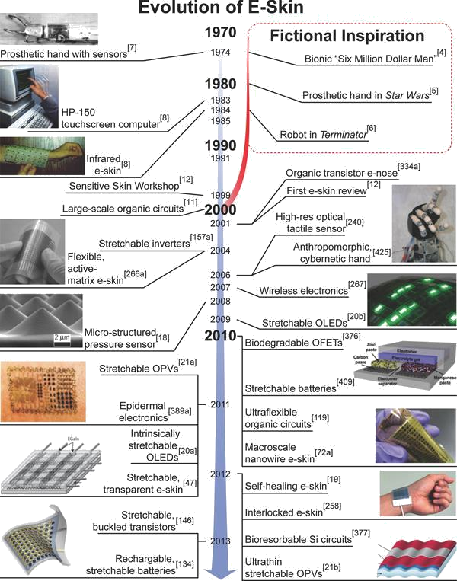

**Fig.2.1:** Evolution of electronic skin

A brief chronology of the evolution of e-skin shown in fig.a. several science fictional events in popular culture that inspired subsequent critical technological advancements in the development of e-skin are emphasized: micro- structured pressure sensor, stretchable O LED s, stretchable O PV s, sretchable, transparent e-skin‖ , macroscale manoeuvres, e-skin‖, rechargeable, stretchable batteries‖, interlocked e-skin.

This paper focuses on the Artificial skin(E-Skin) to build a skin work similar to that of the human skin and also it is embedded with several sensations or the sense of touch acting on the skin. This skin is already being stitched together. It consists of millions of embedded electronic measuring devices: thermostats, pressure gauges, pollution detectors, cameras, microphones, glucose sensors, EKGs, electronic holographs. This device would enhance the new technology which is emerging and would greatly increase the usefulness of robotic probes in areas where the human cannot venture.

The sensor could pave the way for a overabundance of new applications that can wirelessly monitor the vitals and body movements of a patient sending information directly to a computer that can log and store data to better assist in future decisions. This paper offers an insight view of the internal structure, fabrication process and different manufacturing processes.

**CHAPTER 3**

# Architecture of Electronic skin

With the interactive e-skin, demonstration is takes place an elegant system on plastic that can be wrapped around different objects to enable a new form of HMI. Other companies, including Massachusetts-based engineering firm MC10, have created flexible electronic circuits that are attached to a wearer's skin using a rubber stamp. MC10 originally designed the tattoos, called Biostamps, to help medical teams measure the health of their patients either remotely, or without the need for large expensive machinery. Fig 2 shows the various parts that make up the MC10 electronic tattoo called the Biostamp. It can be stuck to the body using a rubber stamp, and protected using spray-on bandages. The circuit can be worn for two weeks and Motorola believes this makes it perfect for authentication purposes.

Flexible Electronic Skins Biostamp use high-performance silicon, can stretch up to 200 per cent and can monitor temperature, hydration and strain, among other medical statistics. Javey's study claims that while building sensors into networks isn't new, interactive displays; being able to recognize touch and pressure and have the flexible circuit respond to it is 'breakthrough'. His team is now working on a sample that could also register and respond to changes in temperature and light to make the skin even more lifelike.

Large-area ultrasonic sensor arrays that could keep both robots and humans out of trouble. An ultrasonic skin covering an entire robot body could work as a 360-degree proximity sensor, measuring the distance between the robot and external obstacles. This could prevent the robot from crashing into walls or allow it to handle our soft, fragile human bodies with more care. For humans, it could provide prosthetics or garments that are hyperaware of their surroundings. Besides adding multiple functions to e-skins, it’s also important to improve their electronic properties, such as the speed at which signals can be read from the sensors. For that, electron mobility is a fundamental limiting factor, so some researchers are seeking to create flexible

materials that allow electrons to move very quickly.

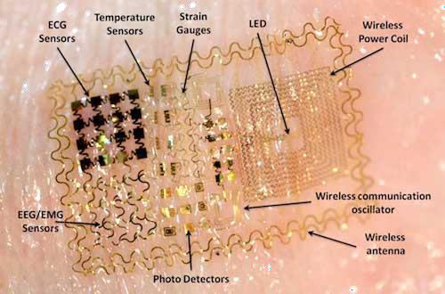

**Fig.3.1:** Architecture & components involved in Electronic skin

Ali Javey and his colleagues at the University of California, Berkeley, have hadsome success in that area. They figured out how to make flexible, large-area electronics by printing semiconducting nano wires onto plastics and paper. Nanowires have excellent electron mobility, but they hadn’t been used in large-area electronics before. Materials like the ones Javey developed will also allow for fascinating new functions for e-skins. My team has developed electromagnetic coupling technology for e-skin, which would enable wireless power transmission.

Imagine being able to charge your prosthetic arm by resting your hand on a charging pad on your desk. In principle, any sort of conductor could work for this, but if materials with higher electron mobility are used, the transmission frequency could increase, resulting in more efficient coupling. Linking sensors with radio- frequency communication modules within an e-skin would also allow the wireless transmission of information from skin to computer—or, conceivably, to other e- skinned people.

Electronic skins for robots and medical prostheses—multifunctional structures, in which sensors and actuators are closely integrated with microelectronic circuits— bring a new dimension to electronics flexibility. Shaped electronics and skin-like.

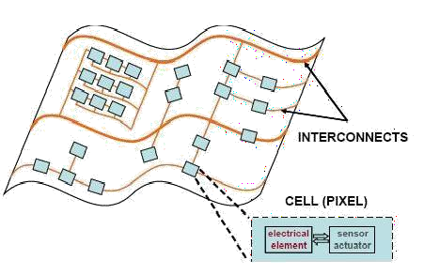.

fig 3.2 : island carrying electronic surface

The achieve flexible and stretchable skin, sub circuit cells, made of a transducer and an electronic circuit, will be placed on mechanically separated islands, which are fabricated on a deformable substrate that takes up most of the total strain. The figure shown above is a sketch of such an island carrying electronic surface. The islands are made sufficiently rigid to protect them from breaking when the circuit is deformed one time or by repeated stretching. The sub circuits are electrically connected with stretchable metal conductors.

We have three options for making deformable interconnects: making thin metal films that can withstand large plastic deformation, deforming a sacrificial mask which serves in liftoff metallization, and making stretchable metallization.

### CHAPTER 4

**FABRICATION OF ELECTRONIC SKIN**

U.S. and Chinese Scientists used zinc oxide vertical nanowires to generate sensitivity. According to experts, the artificial skin is "smarter and similar to human skin." It also offers greater sensitivity and resolution than current commercially available techniques. A group of Chinese and American scientists created experimental sensors to give robots artificial skin capable of feeling. According to experts, the sensitivity is comparable to that experienced by humans. Trying to replicate the body's senses and indeed its largest organ, the skin, has been no mean feat but the need for such a substitute has been needed for a while now, especially in cases of those to whom skin grafts have not worked or indeed its use in robotics.

To achieve this sensitivity, researchers created a sort of flexible and transparent electronics sheet of about eight thousand transistors using vertical nanowires of zinc oxide. Each transistor can directly convert mechanical motion and touch into signals that are controlled electronically, the creators explained."Any mechanical movement, like the movement of an arm or fingers of a robot, can be converted into control signals," the Professor Georgia Institute of Technology (USA), Zhong Lin Wang.

The technology "could make smarter artificial skin similar to human skin," said Zhong, after stating that it provides greater sensitivity and resolution. The system is based on piezoelectricity, a phenomenon that occurs when materials such as zinc oxide are pressed. Changes in the electrical polarization of the mass can be captured and translated into electrical signals thereby creating an artificial touch feeling.

The electronic skin uses thin single-crystal silicon that has superior flexibility and a mobility equivalent to that of the silicon used in personal portable devices. The approach, a printing method developed previously by Roger's group could be called inking and printing. As shown in fig.d.

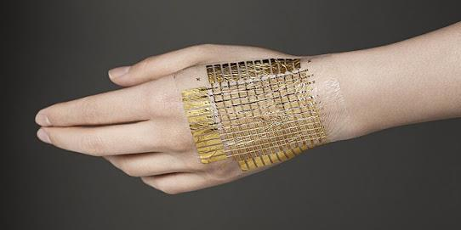

Fig.4.1: Fabrication of e-skin on human hand

A thin silicon layer is bonded to a silicon dioxide release layer. The silicon layer

is cut into a lattice of micrometer-scale chiplets, a transfer stam player is then attached to the top of the divided silicon. The transfer layer and chiplets are then lifted and transferred to a flexible substrate. Attaching electronic skin to natural skin is more difficult than attaching it to robots or prosthetics. Natural skin is soft and delicate and already has touch-sensing functions. The electronic skin that can be used for physiological monitoring must have a supporting layer with mechanical properties that match those of natural skin to avoid any discomfort resulting from long wearing. The electronic skin must not be too thick, too rigid, too hard, or too heavy, but must have conformal contact,

Intimate integration, and adequate adhesion with the natural skin. Special materials that are properly designed through accurate modeling were needed to achieve these properties. The support layer of the electronic skin is an elastomeric (rubbery) polyester engineered to have mechanical properties well matched to those of natural skin. The circuitry part of the electronic skin consists of two protection layers that sandwich a multifunctional middle layer. With their equal thicknesses, the protection layers develop opposite strains that cancel, so the middle circuit layer experiences little stress no matter which direction the device is bent. The middle layer consists of the metal, semiconductor, and insulator components needed for sensors, electronics, power supplies, and light-emitting components, all of which are in the serpentine shape that forms a stretchable net. The serpentine shapes allow the net to deform drastically with little effect on its functionality.

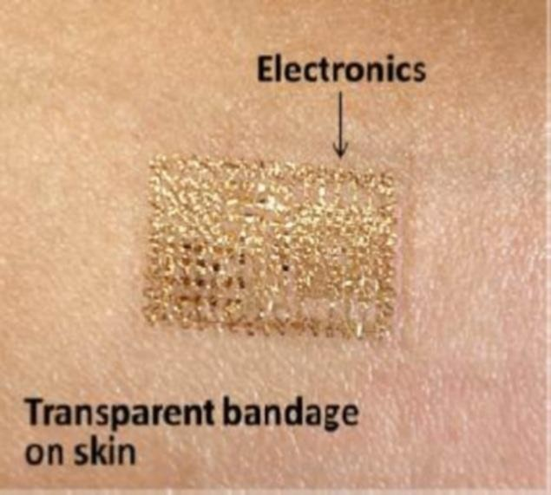

Fig.4.2. Transparent Bandage of skin



This innovative design contains all of the necessary components in an ultrathin layer about the thickness of a human hair. The electronic skin can be simply mounted onto or peeled off natural skin in the same way

As Bandage tape as shown in fig.4.2.

Physiological information has been collected from heart, brain, and skeletal muscles with a quality equivalent to that collected with bulky electrodes and hardware. Other forms of physiological information collection based on the electronic skin are readily feasible because they could use components that have more sophisticated functions. The transfer-printing fabrication approach has proved to be viable and low-cost in this demonstration, which will greatly facilitate the practical clinical use of the electronic skin. Because of the higher quality of the transferable thin silicon, wireless communication directly from the electronic skin should be feasible, given recent demonstrations of this capability in other devices shown in fig.e

Other types of electronic skins with applications beyond physiology, such as body heat harvesting and wearable radios, may also point to interesting directions for future work as shown in figure f.

Dept of E.C.E,S.S.N.E.C Ongole Page 11

.

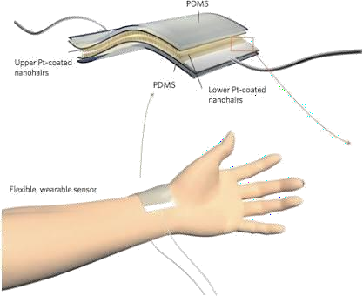

Fig.4.3. Flexible wearable sensor

Flexible wearable sensor are senors which can wear to sense any moments obtained frominside the body and outside the body. And these sensor exhibits flexible as like as normal human skin that how it stretches and bends. It has a sheet like structure which is intractable with the outer surface of the body as shown in figure.4.3.

**CHAPTER 5**

**FEATURES OF ELECTRONIC SKIN**

The electronic skin concept was initially developed for applications in robotics.Robots could be provided with pressure sensing.(Touch‖)that would alow them to grip objects securely w it hout damaging them (the picking up an egg ‖ problem ). T hese electronic skins, which mainly consist of pressure - sensing materials and associated electronic devices for pressure reading, might also provide touch sense to prosthetic devices such as artificial legs or arms.

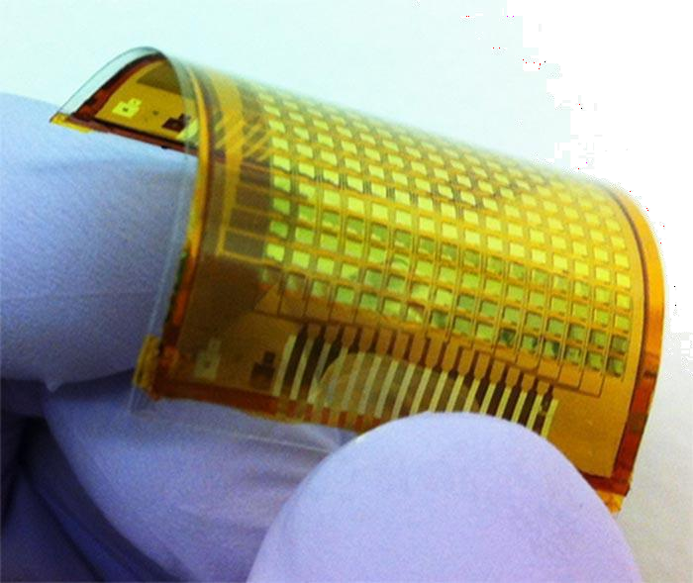

Fig.5.1 twisted e-skin

One challenge for making these devices is that the tr ansistors (and the semiconductors in them) that a mplify weak signals must be flexible in order to act lik e skin. The ability of tr ansistors to amplify signals, their gain depends on the mobility of the charge carriers in their semiconductor under the gate layer (or in their gated semiconductor la yer). Doped single-crystalline silicon wafers are used in most computer chips because of their high carrier mobility , which allows oper ation with low applied voltage and low power. However, the wafers are brittle, so alternative materials have been pursued. Some of the candidate flexible semiconductors, such as conducting polymers have much

lower carrier mobility.The higher voltages needed to use these materials as tr ansistors ma y not be suitable for electronic skin that mak es direct contact with a patient’s skin, and ma y quickly exhaust small power supplies. Another approach is to convert brittle semiconductors into more flexible froms. For example, silicon and germanium are highly flexible as nano wires. However, their carrier mobility , although much higher than that of conducting polymers, is still much lower than that of doped silicon. With these types of materials, it is difficult or impossible to achieve the performance needed to amplify very weak signals acquired from natur al skin.: GBUI SYMBOLS

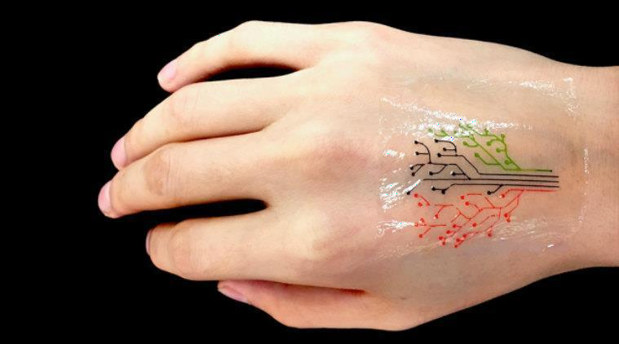

The electronic skin uses thin single-crystal silicon that has superior flexibility and a mobility equivalent to that of the silicon used in personal portable devices. A thin silicon la yer is bonded to a silicon dioxide release la yer. The silicon la yer is cut into a lattice of micrometer-scale chiplets, and a transfer stam player is then attached to the top of the divided silicon. The transfer layer and chiplets are then lifted and tr ansferred to a flexible s ubstrate. Attaching electronic skin to natur al skin is more difficult than attaching it to

or prosthetics. Natur al skin is soft and delicate a nd already has touch-sensing functions. The electronic skin that can be used for ph ysiological monitoring must have a supporting la yer with mechanical properties that match those of natur al skin to avoid any discomfort resulting from long wearing. The electronic skin must not be too thick, too rigid, too hard, or too heavy , but must have conformal contact, intimate integr ation, and adequate adhesion with the natur al skin. Special materials that are properly designed through accurate modeling were needed to achieve these properties. The support la yer of the electronic skin is an elastomeric (rubbery) polyester engineered to have mechanical properties well matched to those of natur al skin. The circuitry part of the electronic skin consists of two protection layers that sandwich a multifunctional middle layer. With their equal thicknesses, the protection la yers develop opposite str ains that cancel, so the middle circuit la yer experiences little stress no matter which dire ction the device is bent. The middle la yer consists of the metal, semiconductor, and insulator components needed for sensors, electronics, power supplies, and light-emitting components, all of which are in the serpentine shape that forms a stretchable net. The serpentine shapes allow the net to deform dr astically with little effect on its functionality.

This innovative design contains all of the necessary components in an ultr athin layer about the thickness of a human hair. The electronic skin can be simply mounted onto or peeled off natur al skin in the same way as bandage tape. Ph ysiological information has been collected from heart, br ain, and skeletal muscles with a quality equivalent to that collected with bulky electrodes and hardware. Other forms of ph ysiological information collection based on the electronic skin are readily feasible because they could use components that have more sophisticated functions. The tr ansfer printing

fabrication approach has proved to be viable and low-cost in this demonstr- ation, which will greatly facilitate the pr actical clinical use of the electronic skin

.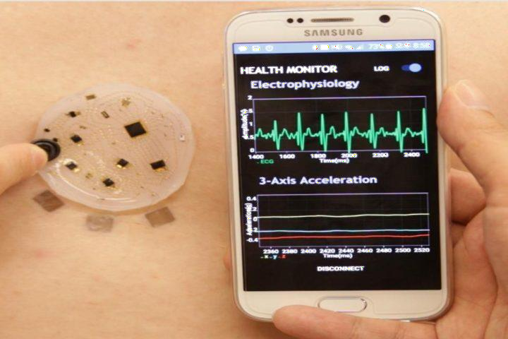

Fig .5.2 monitoring of waves .

Because of the higher quality of the transferable thin silicon, wireless communication directly from the electronic skin should be feasible, given recent demonstrations of this capability in other devices .Other types of electronic skins with applications beyond physiology, such as body heat harvesting and wear able radios, may also point to interesting directions for future work.

### CHAPTER 6

**DESIRABLE PROPERTIES OF E-SKIN**

E-skin can mimic the properties of human skin in its ability to sense tactile forces, as well as augment the capabilities of human skin through incorporation of chemical and biological sensing functionalities.

### Biocompatibility and Biodegr adability:

Since e-skin applications require intimate association with biological interfaces, biocompatibility is an important consider ation for such devices. Ideally, e- skin should be synthesized from highly biocompatible components.

### Self -healing:

While naturally occurring human skin has the ability to repair itself after incurring mechanical damage, this property has yet to be fully realized in e-skin. F or artificial skin, the ability to repair both mechanical and electrical damage would be highly advantageous for practical applications. There are two predominant strategies used to incorporate self-healing properties into materials, namely: 1) the use of material s loaded with healing agents and 2) the use omaterials containing dynamic reversible bonds. The incorpor ation of capsules containing healants was first demonstr ated in self-healing, non-conducting polymers. However, for e-skin applications, it is necessary to use a system that is electrically active.

### Temperature sensitivity:

Sensing temper ature is a key functionality of human skin that helps to prevent injury and provides infor mation about the surrounding environment, most tactile sensors are inherently temper ature sensitive, and their r esponse must therefore be calibrated with a temperature sensor. Several groups have implemented piezoelectric pysoelectric sensors that can discriminate between

temperature and pressure inputs. Resistive temperature detectors (RTD) are attractive for e-skin applications owing to their flexibility, simple device structure, and compatibility with electronic readout methods.

relate a change in temper ature to a corresponding resistance change through a material commonly composed of metals such as A u and platinum (Pt). T o deconvolute the contribution of tactile stimuli from temper ature sensors, meandering sections of Pt as temper ature-sensing devices were implemented. These devices achieved a resolution of 0.03 °C over a wide range of temperatures.

### Stretchable Temperature sensors:

Based on thin, buckled A u lines are also demonstrated. While the linear behavior of this sensor was attractive, the change in resistance was relatively small, and would require a sensitive readout mechanism.

### Self – Powering:

Providing a long-lasting supply of power is a persistent challenge for mobile electronics. As the largest human organ, skin provides a large area for potential energy stor age. Furthermore, as the body’ s interface with the outside world, e-skins may provide the opportunity to scavenge energy from environmental sources such as light and mechanical forces. A number of promising technologies have recently been demonstrated for power generation, transmission, and stor age in stretchable systems, including solar cells, m echanical energy harvesters, supercapacitors, batteries, and wireless antennas.

Light is a readily available power source, and is most effectively harvested using devices with large surface area. stretchable solar cells based on rigid GaAs device islands connected with freestanding metal interconnects are determined . These solar cells oper ated with an efficiency of 13% with applied str ain of up to 20%. Although these devices provided exceptiona l performance, the high cost of GaAs ma y limit its implementation in large-area e-skins. OPV s on ultrathin substrates using conventional materials and processes are fabricated. By transferring the devices to a prestretched substr ate, they were able to achieve a stretchability up to 400% with an efficiency of 4%.

Technologies for harnessing mechanical energy include both dielectric elastomer generators and piezoelectric generators. Dielectric elastomer generators consist of an elastomeric dielectric coated with two highly compliant electrodes, and their stretchability makes them attractive for use in e-skin. The electrodes are charged by applying a voltage in the compressed st ate. Relaxation of the elastomer increases the voltage, producing higher energy charges that are harvested. Dielectric elastomer gener ators can achieve very high efficiencies, but have historically been limited b y the complexity and weight of the associated electronics. Recent rep orts have demonstrated that the circuit complexity can be reduced using systems that are self-primed or primed by electrets. Mechanical energy harvesting devices based on nanostructured piezoelectric materials have also been developed, and stretchable versions have been fabricated by buckling the active materials. Fueled by the development of new soft materials, the field of mechanically compliant energy storage technologies has recently emerged. Supercapacitors store energy in the form ofdouble layers of charged species residin g at the electrode– electrolyte interface and provide very high power densities. Buckled CNT electrodes on prestrained substrates have been used to make supercapacitors that are stretchable up to

30%.

### CHAPTER 7

**ORGANIC LED IN ELECTRONIC SKIN**

Searchers combined a conductive, pressure-sensitive rubber material, organic light Javey and colleagues set out to make the electronic skin respond optically. The reemitting diodes (OLEDs), and thin-film transistors made of semiconductor-enriched carbon nanotubes to build an array of pressure sensing, light-emitting pixels. Whereas a system with this kind of function is relatively simple to fabricate on a silicon surface, ―for plastics, this is one of the more complex systems that has ever been demonstrated,‖ says Javey.

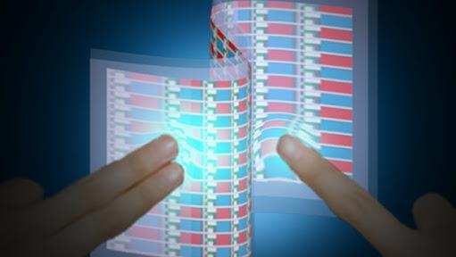

Fig 7.1: OLED of electronic skin

The diversity of materials and components that the researchers combined to make the light-emitting pressure-sensor array is impressive, says John Rogers, a professor of materials science at the University of Illinois at Urbana-Champaign. Rogers, whose group has produced its own impressive flexible electronic sensors (see

―Electronic Sensors Printed Directly on the Skin‖), says the result illustrates how research in

Nano materials is transitioning from the fundamental study of components and simple devices to the development of ―sophisticated, macroscale demonstrator devices, with unique function.‖ In this artist's illustration of the University of California, Berkeley's interactive e-skin, the brightness of the light directly corresponds to how hard the surface is pressed. Semiconducting material and transistors are fitted to flexible silicon to mimic pressure on human skin.

### 7.1 Flexible electronic skin:

The team is working on samples that respond to temperature. Scientists have created what's been dubbed the world's first interactive 'electronic skin' that responds to touch and pressure. When the flexible skin is touched, bent or pressed, built-in LED’s light up - and the stronger the pressure, the brighter the light. The researchers, from the University of California, claim the bendy e-skin could be used to restore feeling for people with prosthetic limbs, in smart phone displays, car dashboards or used to give robots a sense of touch. Scientists from the University of California have created what's been dubbed the first 'electronic skin' that responds to touch and pressure by lighting up using built-in lights.

### CHAPTER 8

**ADVANTAGES & APPLICATIONS**

### Advantages of Electronic Skin:

* + - Possibly can return feeling to patients with transplants
    - Can make robots more sensitive, enabling them to carry out a variety of new functions
    - Use of tiny electronic wires allows skin to generate impulses, similar to that of the body's own Nervous System
    - Increases flexibility of artificial skin (compared to others of different materials)
    - Could lead to advancements in medical equipment

### Disadvantages of Electronic Skin:

* + - As it is not readily available, could be extremely expensive
    - Maitenance could be even more costly
    - Defects in robots with the electronic skin could lead to accidents (with new functions)
    - Connecting skin to brain may be difficult in some patients
    - Although the idea of using it as human transplants is in the works, it may be more difficult in practice

**CHAPTER 9**

## CONCLUSION

In the past decade, the pace of e-skin development has accelerated dramatically owing to the availability of new materials and processes. As a result of this progress, the capabilities of e-skin are rapidly converging. Interest in e-skin has been driven by its potential to:

1. enable highly the development of inter active and versatile robots that are capable of performing complex tasks in less structured environments.
2. facilitate conformable displays and optics. and
3. revolutionize healthcare by providing biometric prostheses, constant health monitoring technologies, and unprecedented diagnostic and treatment proficiency. Sensor and circuits have already exceeded the properties of biological skin in man y respects. Electronic devices have been fabricated that stretch many times further than skin, flexible tactile sensors have been demonstrated that possess vastly superior spatial resolution to human skin, and tactile and temper ature sensors are available with enhanced sensitivity o ver their natural counterpart. Despite rapid progress, there is a continuing need for further development before the goal of integrating multiple functionalities into large- area, low-cost sensor arrays is realized. From a design standpoint, e-skin requires active circuitry to address large numbers of devices with minimal wiring complexity and fast scan rates. Furthermore, the ability to mimic th e mechanical properties of human skin (e.g., flexibility and stretchability) is critical in order to accommodate the various movements of the user. This can be accomplished through the use of intrinsically strechable materials or rigid device islands tethered together through flexible interconnects. While the latter lever ages the extensive optimization of rigid devices, the former may have advantages in terms of cost and robustness.

### REFERENCES

* + A.K. Jain, A. Ross, K. Nandakumar, Introduction to Biometrics, Springer, 2011.
  + K. O'Hara et al., "Touchless interaction in surgery", Communications of the ACM, vol. 57, no. 1, pp. 70-77, 2014.
  + J. Wachs, H. Stern, Y. Edan, M. Gillam, C. Feied, M. Smith, J. Handler, "Real- Time Hand Gesture Interface for Browsing Medical Images". IC-MED, vol. 1, no. 3, pp. 175-185.
  + P. Peltonen, E. Kurvinen, A. Salovaara, G. Jacucci, T. Ilmonen, J. Evans, A. Oulasvirta, P. Saarikko, "It's mine don't touch!: interactions at a large multi-touch display in a city centre", CHI '08: Proceeding of the twenty-sixth annual SIGCHI conference on Human factors in computing systems, ACM, pp. 1285-1294, 2008.

Dept of E.C.E, S.S.N.E.C Ongole Page 24